Digital transformation and how it enables industry 4.0

When we talk about digital transformation from the perspective of an average person , it means applying digital technologies to every aspect of society and more specifically business. However, in the macro sense digital transformation is much more than just that. Its about an inevitable change and how that change will impact the daily lives of people , a transformation that transcends all barriers and boundaries to leave a profound impact for generations.

In concise and precise words, Digital transformation is the process of adopting new and innovative technological advances and investing in them to drive growth in new and existing markets with the aim of transforming and evolving more effectively in an ever-changing digital economy.

It is a journey with the vision of leveraging technologies and developing new competencies that are more customer-centric , streamlined, innovative and efficient in a way that strives towards providing ubiquitous optimization , operational flexibility and an enhanced commoditization .

Our world is smart and digital . Every other day we are introduced to some new technology that improves or replaces the one which existed before and all this is to make our lives easier. We expect technology to do anything and everything we desire and mostly it does. But its when it doesn’t that we feel its absence the most.

That is why companies have to make investments in technologies that can meet the requirements of the consumers in the way they expect. Adopting innovative ideas and tech leads to improved customer-experience which in turn leads to increased demand of even newer technologies because the customers have grown accustomed to the digital world. Now this is where digital transformation comes into picture.

Digital transformation is undoubtedly an indomitable advancing march of technology. It entails the use of creative elements and convergence of modern technologies and then fusing them into a congruent vision and business strategy that allows companies to take market shares from competitors , enter new markets and opens a whole new realm for plethora of possibilities providing a firm for differentiation and growth.

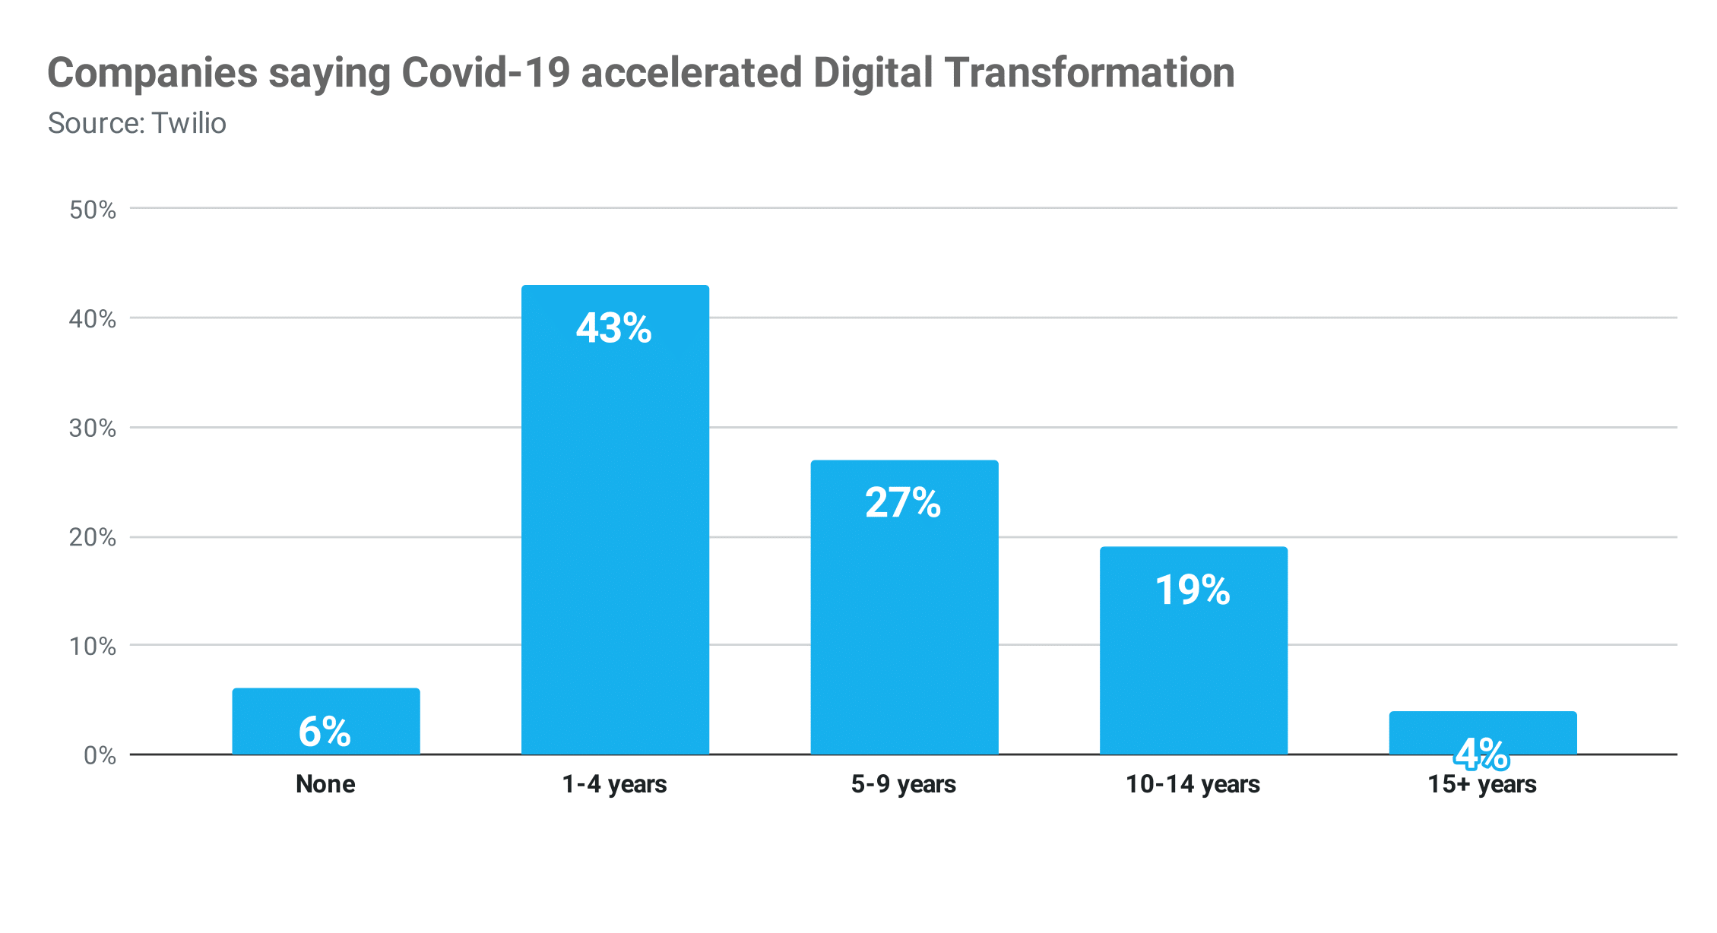

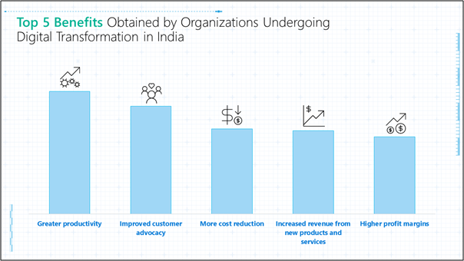

**~**Relation between Digital Transformation and Industry 4.0

Now the question we are faced with is how is digital transformation synonymous with Industry 4.0?

Industries are under constant pressure to improve product quality, boost efficiency, stay competitive, enhance safety, security and sustainability, all while remaining profitable . And as we know Industry 4.0 is about the significant transformation taking place to meet the aforementioned needs.

The transition to Industry 4.0 will depend on a successful adoption of many new technologies, which is to say , digital transformation. To enable smart manufacturing, and make factories more efficient ,resourceful and highly flexible digital twins of machines and operations will be essential , as will factory automation and real-time control of equipment and tasks.

Digital transformation in the Industry 4.0 era will improve the competitiveness of industrial organizations, at the same time boosting their ability to make optimal decisions.

 Digitization will be a key step towards shaping a successful digital transformation strategy. It will help change supply chain management and the people partly independent of each other in the complex supply chain will become networked, collaborate together at a faster pace, and exchange information in real time via a common infrastructure All that was unthinkable just a few years ago would be made possible. It's a challenge that is immense, but if successfully implemented, just as promising.

 Change is inevitable and sooner or later we have to accept that data is not lying, that markets and business models are accelerating rapidly, and that digitization is not simply updating the past, but brings something new along , in simple words, the need of the hour.

